Dear Delegates,
We are very much looking forward to welcoming you our Special Interest Conference on Precision Engineering for Sustainability at Glasgow Caledonian University, Glasgow, Scotland.

To help you with your planning, we have provided a summary of key information for the meeting.
Venue address:
70 Cowcaddens Road,
Glasgow, G4 0BA
Scotland, UK
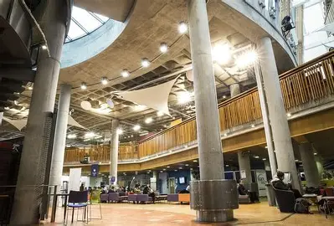
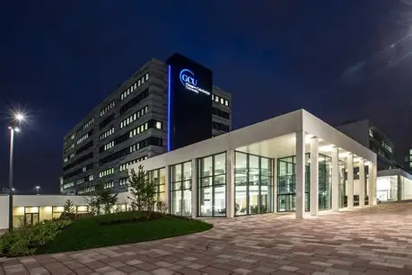
Registration

Upon arrival, please proceed to the registration desk, which will be in the Centre of Executive Education building, within rooms CEE 15-16. Our team will be there to greet you and provide guidance on where to go next. You will be directed to the appropriate room once inside the building.

More useful information can be found here from GCU.

Registration time: 08:15 – 09:00

You will receive a delegate badge for access. Please bring this badge with you on both days of the event.

Oral presenters
In the unlikely event you have not submitted your presentation in advance of arrival, these must be handed in to a member of euspen staff or helper on a flash drive/USB stick at registration. Please note that presentations should be submitted as early as possible before the assigned presentation time to allow minimum disruption to the agenda. Presentations should be in PowerPoint format only.

Poster presenters

Posters will be displayed throughout the event with the programme incorporating dedicated timings to allow delegates the opportunity to view and discuss your poster.

If you have been awarded a poster presentation, please find your allocated poster number on the attached document. Posters will be positioned in the lobby and poster presentation guidelines can be found here.

Laboratory tours
The laboratory tours of GCU will take place on Wednesday, 2nd September 2026. Tours are included in your registration fee.
Tour Time: 16:30-17:30
The laboratory tours are included as part of the programme and you will be directed by euspen staff and GCU associates, who will guide you through the tour.

Networking dinner – Wednesday 2nd September 2026.

The evening Networking Dinner will be held at the Bothy.
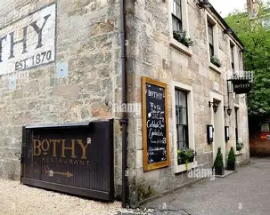
The Bothy is a quintessential Scottish bolthole, a well-established culinary institution tucked away from the throng of the busy West End and discovered via the charming cobbles of Ruthven Lane.
With a menu driven by provenance and passion, you can always expect to find seasonal Scottish produce at the heart of our dishes. No dinner is complete without a dram, so you can also expect to find a carefully curated drinks menu, packed full of Scottish whisky, gins, locally distilled spirits and more. Ingredients are sourced are from all over Scotland, with beef from the stormy Island of Orkney to cheese from the beautiful Isle of Arran.

Address: 11 Ruthven Ln, Glasgow G12 9BG

Please ensure you bring your delegate badge with you to this event and have informed euspen staff of any dietary requirements beforehand.

Travel Information
Information on hotels and travel can be found on our website here.

On behalf of the euspen team and the organising committee, we wish each of you a pleasant and safe journey and look forward to meeting you soon.

