Type the text here (In lower case) calibri 14, single line spacing

Type the authors first names & surnames (remember ^{1, 2 or 3)} calibri 11, single line spacing

¹Type the affiliation of all the authors (remember ^{1, 2 or 3}) calibri 8, italic, single line spacing

Type the email address of the submitting author calibri 8, italic, single line spacing

Abstract
Insert your abstract in this section calibri 9, single line spacing

This is the template for euspen’s international conference proceedings. Please use these formats to ensure that your article does not exceed the page limit. The number of pages per extended abstract should be either 2 or 4 pages, no other combination will be excepted.

Type the keywords here calibri 8, single line spacing

Font: Calibri 9, justified, line spacing: single unless otherwise stated

1. Main section heading Bold, space 12pt bef., 3pt aft., 1.5 line
Insert your introduction here. The introduction begins broadly and funnels down to the transition to the rest of the paper. It begins by identifying an important problem in society. Next it frames the question analysed in the paper. Next it summarizes previous work and describes why this research is different from previous work; this is a brief literature review. Finally, it summarizes exactly what will follow in the paper; generally using one sentence to summarize each of the sections that follow. First line by 0.25cm

2. Main section heading
Do not forget to include your methodology. It is exceedingly important that all readers clearly understand your methodology. The methodology section frequently contains a series of numbered equations containing variables. Define all variables. Do not use numeric values, numeric examples or include results in this section. Do not repeat equations; refer to equations by equation number. List all assumptions. Identify the limitations of the methodology. Use as many sections and subsections as needed to organize the methodology.

2.1. Second level heading Bold, italic
This example should be used for any second level headings. This is the template for euspen’s international conference proceedings. Please use these formats to ensure that your article does not exceed the page limit. This is the template for euspen’s international conference proceedings. Please use these formats to ensure that your article does not exceed the page limit. This is the template for euspen’s international conference proceedings. Please use these formats to ensure that your article does not exceed the page limit.
This is the template for euspen’s international conference proceedings. Please use these formats to ensure that your article does not exceed the page limit.
High-res images should be kept within column/page margins
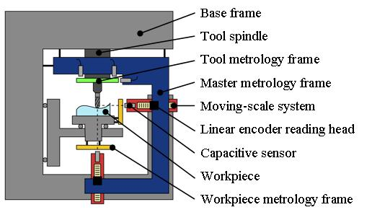

Figure 1. (note: larger figures can be set over 2 text columns) calibri 8

2.2. Third level heading
This example should be used for any third level headings. This is the template for euspen’s international conference proceedings. Please use these formats to ensure that your article does not exceed the page limit. This is the template for euspen’s international conference proceedings. Please use these formats to ensure that your article does not exceed the page limit.

High-res mages should be kept within column/page margins
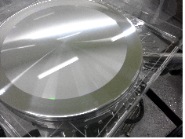

Figure 2. (note: larger figures can be set over 2 text columns) calibri 8

3. Main section heading
This is the template for euspen’s international conference proceedings. Please use these formats to ensure that your article does not exceed the page limit.

Table 1 (note: larger tables can be set over 2 text columns) calibri 8

Component |  | Uk = 2/nm
Affecting reproducibility | Thermal erorrs for ΔT = 0.5 °C | 37
 | Dynamic errors and sensor noise | 9
 | Non-repeatable geometric errors | 5

4. Main section heading
Remember to include results. Apply the methodology to generate numeric results. If measured data are available, compare the numeric results to measured results. Comment on agreement between theoretical and measured results.

5. Main section heading
The summary, conclusion and future work are all different and are all important. First summarise the paper. The summary should be similar to the last section of the Introduction, but should usually contain important numeric results Next, state explicitly what the reader should conclude from the work. Describe how the work should be interpreted and why it is important. Do not assume that the reader will figure this out on his/her own. Finally, describe what steps you would take to improve the work.

References Bold, calibri 8
All references must be cited, and vice versa.
All tables and figures should be referenced in the text. This helps the reader understand where the figure/table belongs (if it is moved during typesetting to fit the journal formatting) and helps the reader see why the item has been included.
A complete reference should provide your reader with enough information to locate the article concerned and should consist of: surname(s) and initials, date published, title of journal or book, volume number, editors (if any) and, for books, town of publication and publisher (in parentheses), and finally the page numbers. Where there are up to ten authors, all authors' names should be given in the reference list. Where there are more than ten authors, only the first name should appear followed by et al.

In the numerical system you should number your references sequentially through the text. The numbers should be given in square brackets, e.g. [1], [2, 5], [2, 5, 7-11] and one number can be used to refer to several instances of the same reference. The reference list at the end of the article lists the references in numerical order, not alphabetically. Journal name should be italic, volume numbers should be in bold.

Examples:
[1] Strite S and Morkoc H 1992 J. Vac. Sci. Technol. B 10 1237-39
[2] Jain S C, Willander M, Narayan J and van Overstraeten R 2000 J. Appl. Phys. 87 965
[3] Kendall M A F and Quinlan N J 2004 Intradermal ballistic delivery of micro-particles into excised human skin for drug and vaccine applications J. Biomech. 37 1733-41
[4] Nakamura S, Senoh M, Nagahama S, Iwase N, Yamada T, Matsushita T, Kiyoku H and Sugimoto Y 1996 Japan. J. Appl. Phys. 35 L7

